**Lab Exercises**

Class: 软件1802班 Name: 范晨光 StuID： 201816040213

Date: 2019.11.10 Score:

**Lab Exercise 1 — Modifying Class Account**

**I Lab Objectives**

In this lab, you will practice:

1. Creating member functions.
2. Invoking functions and receiving return values from functions.
3. Testing a condition using an if statement.
4. Outputting variables with stream insertion and the cout object.

**II Description of the Problem**

Modify class Account to provide a member function called debit that withdraws money from an Account. Ensure that the debit amount does not exceed the Account’s balance. If it does, the balance should be left unchanged and the function should print a message indicating "Debit amount exceeded account balance." Modify class AccountTest to test member function debit.

**III Sample Output**

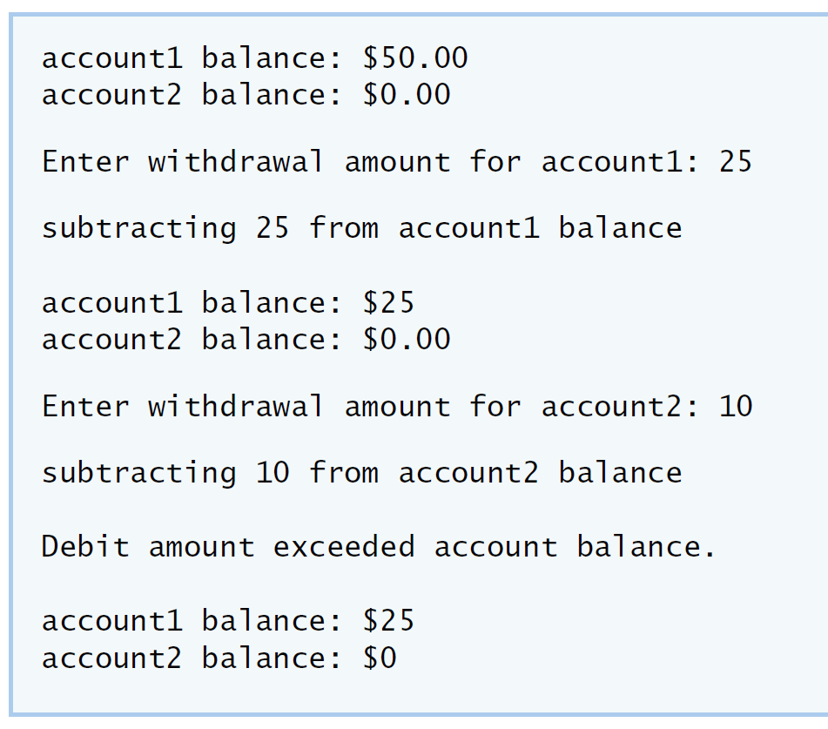

**IV Your Solution**

// Lab 1: Account.h

// Definition of Account class.

class Account

{

public:

Account( int ); // constructor initializes balance

void credit( int ); // add an amount to the account balance

void debit( int );// withdrawal an amount to the account balance

int getBalance(); // return the account balance

private:

int balance; // data member that stores the balance

}; // end class Account

// Lab 1: Account.cpp

// Member-function definitions for class Account.

#include <iostream>

#include "Account.h" // include definition of class Account

using namespace std;

// Account constructor initializes data member balance

Account::Account( int initialBalance )

{

balance = 0; // assume that the balance begins at 0

// if initialBalance is greater than 0, set this value as the

// balance of the Account; otherwise, balance remains 0

if ( initialBalance > 0 )

balance = initialBalance;

// if initialBalance is negative, print error message

if ( initialBalance < 0 )

cout << "Error: Initial balance cannot be negative.\n" << endl;

} // end Account constructor

// credit (add) an amount to the account balance

void Account::credit( int amount )

{

balance = balance + amount; // add amount to balance

} // end function credit

// withdrawal an amount to the account balance

void Account::debit( int WithdrawalAmount)

{

if(balance<WithdrawalAmount)

cout<<"\nDebit amount exceeded account balance.\n\n";

else

balance = balance - WithdrawalAmount;

} // end function debit

// return the account balance

int Account::getBalance()

{

return balance; // gives the value of balance to the calling function

} // end function getBalance

// Lab 1: AccountTest.cpp

// Create and manipulate Account objects.

#include <iostream>

#include "Account.h" // include definition of class Account from Account.h

using namespace std;

// function main begins program execution

int main()

{

Account account1( 50 ); // create Account object

Account account2( 0 ); // create Account object

// display initial balance of each object

cout << "account1 balance: $" << account1.getBalance() << endl;

cout << "account2 balance: $" << account2.getBalance() << endl;

int withdrawalAmount; // stores withdrawal amount read from user

cout << "\nEnter withdrawal amount for account1: "; // prompt

cin >> withdrawalAmount; // obtain user input

cout << "\nsubtracting " << withdrawalAmount

<< " from account1 balance\n\n";

//withdraw money from account1

account1.debit(withdrawalAmount);

// display balances

cout << "account1 balance: $" << account1.getBalance() << endl;

cout << "account2 balance: $" << account2.getBalance() << endl;

cout << "\nEnter withdrawal amount for account2: "; // prompt

cin >> withdrawalAmount; // obtain user input

cout << "\nsubtracting " << withdrawalAmount

<< " from account2 balance\n\n";

//withdraw money from account2

account2.debit(withdrawalAmount);

// display balances

cout << "account1 balance: $" << account1.getBalance() << endl;

cout << "account2 balance: $" << account2.getBalance() << endl;

} // end main

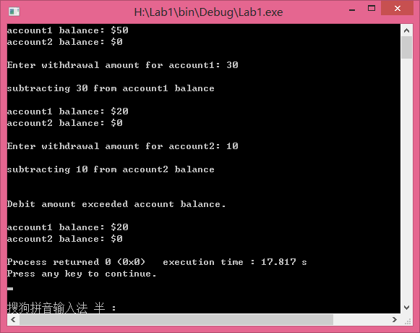**Lab Exercise 2 — Modifying class GradeBook**

**I Lab Objectives**

In this lab, you will practice:

1. Declaring a data member.
2. Providing *set* and *get* functions to manipulate a data member’s value.
3. Declaring member functions with parameters.

**II Description of the Problem**

Modify class GradeBook. Include a second string data member that represents the name of the course’s instructor. Provide a *set* function to change the instructor’s name and a *get* function to retrieve it. Modify the constructor to specify *two* parameters—one for the course name and one for the instructor’s name. Modify member function displayMessage such that it first outputs the welcome message and course name, then outputs "This course is presented by: " followed by the instructor’s name. Modify the test application to demonstrate the class’s new capabilities.

**III Sample Output**

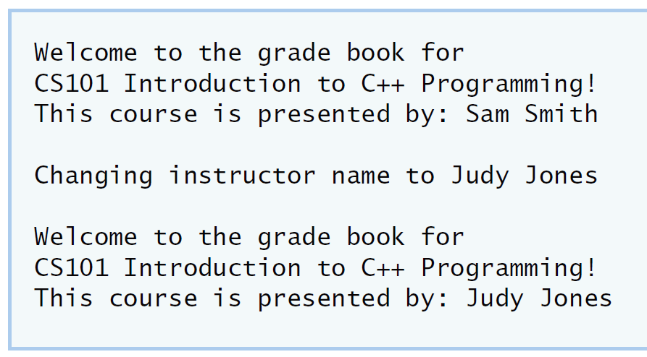

**IV Your Solution**

// Lab 2: GradeBook.h

// Definition of GradeBook class that stores an instructor's name.

#include <string> // program uses C++ standard string class

using namespace std;

// GradeBook class definition

class GradeBook

{

public:

// constructor initializes course name and instructor name

GradeBook( string , string );

void setCourseName( string ); // function to set the course name

string getCourseName(); // function to retrieve the course name

void setInstructorName( string ); //function to set the instructor name

string getInstructorName(); //function to retrieve the instructor name

void displayMessage(); // display welcome message and instructor name

private:

string courseName; // course name for this GradeBook

string instructorName; // instructor name for this GradeBook

}; // end class GradeBook

// Lab 2: GradeBook.cpp

// Member-function definitions for class GradeBook.

#include <iostream>

#include "GradeBook.h"// include definition of class GradeBook from GradeBook.h

using namespace std;

// constructor initializes courseName and instructorName

// with strings supplied as arguments

GradeBook::GradeBook( string course, string instructor )

{

// initializes courseName and instructorName

setCourseName( course );

setInstructorName( instructor );

} // end GradeBook constructor

// function to set the course name

void GradeBook::setCourseName( string name )

{

courseName = name; // store the course name

} // end function setCourseName

// function to retrieve the course name

string GradeBook::getCourseName()

{

return courseName;

} // end function getCourseName

// function to set the instructor name

void GradeBook::setInstructorName( string insname )

{

instructorName = insname; // store the instructor name

} // end function setInstructorName

// function to retrieve the instructor name

string GradeBook::getInstructorName()

{

return instructorName;

} // end function getInstructorName

// display a welcome message and the instructor's name

void GradeBook::displayMessage()

{

// display a welcome message containing the course name

cout << "Welcome to the grade book for\n" << getCourseName() << "!"<< endl;

//output the instructor's name

cout<<"This course is presented by: "<< getInstructorName() <<endl;

} // end function displayMessage

// Lab 2: GradeBookTest.cpp

// Test program for modified GradeBook class.

#include <iostream>

#include "GradeBook.h"// include definition of class GradeBook from GradeBook.h

using namespace std;

// function main begins program execution

int main()

{

// create a GradeBook object; pass a course name and instructor name

GradeBook gradeBook( "CS101 Introduction to C++ Programming" , "Sam Smith");

// display welcome message and instructor's name

gradeBook.displayMessage();

//change instructor's name and output changes

gradeBook.setInstructorName("LeBron James");

cout<<"\nChanging instructor name to "<<gradeBook.getInstructorName()<<"\n\n";

gradeBook.displayMessage();

} // end main

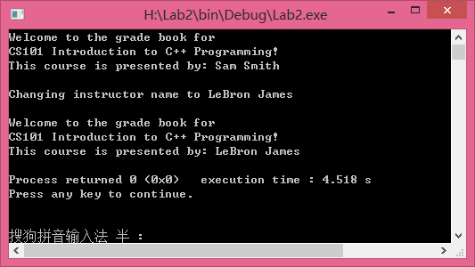

**Lab Exercise 3 — Creating an Employee Class**

**I Lab Objectives**

In this lab, you will practice:

1. Creating a class definition.
2. Declaring data members.
3. Defining a constructor.
4. Defining set and get functions.
5. Writing a test application to demonstrate the capabilities of another class.

**II Description of the Problem**

Create a class called Employee that includes three pieces of information as data members—a first name (type string), a last name (type string) and a monthly salary (type int). Your class should have a constructor that initializes the three data members. Provide a *set* and a *get* function for each data member. If the monthly salary is not positive, set it to 0. Write a test program that demonstrates class Employee’s capabilities. Create two Employee objects and display each object’s yearly salary. Then give each Employee a 10 percent raise and display each Employee’s yearly salary again.

**III Sample Output**

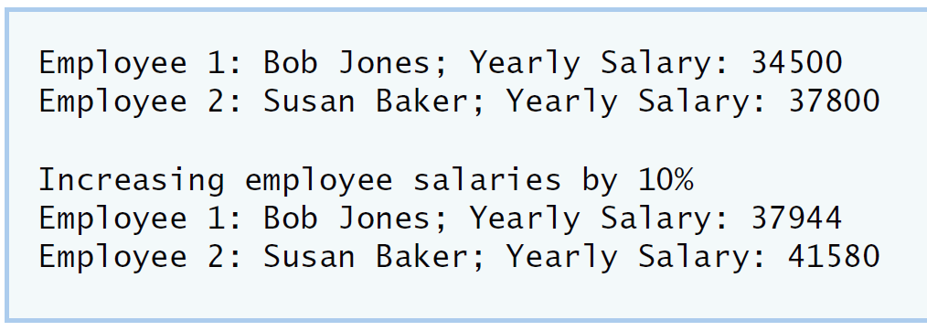

**IV Your Solution**

// Lab 3: Employee.cpp

// Employee class member-function definitions.

#include <iostream>

#include "Employee.h" // Employee class definition

using namespace std;

// Employee constructor

Employee::Employee( string first, string last, int salary )

{

// initializes first, last and monthlySalary

setFirstName( first );

setLastName( last );

setMonthlySalary( salary );

} // end Employee constructor

//function for the first name data member

// Lab 3: Employee.h

// Employee class definition.

#include <string> // program uses C++ standard string class

using namespace std;

// Employee class definition

class Employee

{

public:

Employee( string , string , int );//Employee constructor

void setFirstName( string );// Declare a set method for the employee's first name

string getFirstName();// Declare a get method for the employee's first name

void setLastName( string );// Declare a set method for the employee's last name

string getLastName();//Declare a get method for the employee's last name

void setMonthlySalary( int );//Declare a set method for the employee's monthly salary

int getMonthlySalary();// Declare a get method for the employee's monthly salary

private:

string firstName;// Declare a string data member for the employee's first name

string lastName;// Declare a string data member for the employee's last name

int monthlySalary;// Declare an int data member for the employee's monthly salary

}; // end class Employee

void Employee::setFirstName( string fname )

{

firstName = fname; // store the first name

} // end function setFirstName

//get the first name data member.

string Employee::getFirstName()

{

return firstName;

} // end function getFirstName

//function for the last name data member

void Employee::setLastName( string lname )

{

lastName = lname; // store the last name

} // end function setLastName

//grt the last name data member

string Employee::getLastName()

{

return lastName;

} // end function getLastName

void Employee::setMonthlySalary( int msalary )

{

if(msalary>0)

monthlySalary = msalary; // store the monthly salary

else

monthlySalary = 0;

} // end function setLastName

int Employee::getMonthlySalary()

{

return monthlySalary;

} // end function getLastName

// Lab 3: EmployeeTest.cpp

// Create and manipulate two Employee objects.

#include <iostream>

#include "Employee.h" // include definition of class Employee

using namespace std;

// function main begins program execution

int main()

{

/* Create two Employee objects and assign them to Employee variables. */

Employee employee1("Mike ", "Smith" , 2850);

Employee employee2("John ", "Curry" , 3150);

/* Output the first name, last name and salary for each Employee. */

cout<<"Employee 1: "<<employee1.getFirstName()<<employee1.getLastName()

<<"; Yearly Salary: "<<employee1.getMonthlySalary()*12<<endl;

cout<<"Employee 2: "<<employee2.getFirstName()<<employee2.getLastName()

<<"; Yearly Salary: "<<employee2.getMonthlySalary()*12<<endl;

/* Give each Employee a 10% raise. */

employee1.setMonthlySalary(employee1.getMonthlySalary() * 1.1);

employee2.setMonthlySalary(employee2.getMonthlySalary() * 1.1);

/* Output the first name, last name and salary of each Employee again. */

cout<<"\nIncreasing employee salaries by 10%\n"<<endl;

cout<<"Employee 1: "<<employee1.getFirstName()<<employee1.getLastName()

<<"; Yearly Salary: "<<employee1.getMonthlySalary()*12<<endl;

cout<<"Employee 2: "<<employee2.getFirstName()<<employee2.getLastName()

<<"; Yearly Salary: "<<employee2.getMonthlySalary()*12<<endl;

} // end main

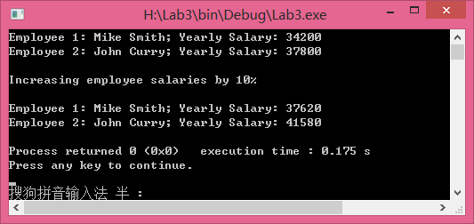**Lab Exercise 4 — Complex Numbers**

**I Lab Objectives**

In this lab, you will practice:

1. Creating new data types by writing class definitions.
2. Defining member functions of programmer-defined classes.
3. Instantiating objects from programmer-defined classes.
4. Calling member functions of programmer-defined classes.

The follow-up questions and activities will also give you practice:

1. Initializing programmer-defined class data members with class constructors.

**II Description of the Problem**

Create a class called Complex for performing arithmetic with complex numbers. Write a program to test your class.

Complex numbers have the form：

realPart + imaginaryPart * *i*

where *i* is

$$\sqrt{-1}$$

Use double variables to represent the private data of the class. Provide a constructor that enables an object of this class to be initialized when it is declared. The constructor should contain default values in case no initializers are provided. Provide public member functions that perform the following tasks:

1) Adding two Complex numbers: The real parts are added together and the imaginary parts are added together.

2) Subtracting two Complex numbers: The real part of the right operand is subtracted from the real part of the left operand and the imaginary part of the right operand is subtracted from the imaginary part of the left operand.

3) Printing Complex numbers in the form (a, b) where a is the real part and b is the imaginary part.

**III Sample Output**

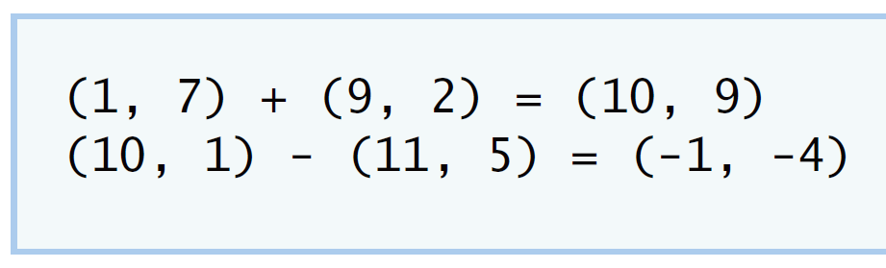

**IV Your Solution**

// Lab 4: Complex.h

#ifndef COMPLEX_H

#define COMPLEX_H

using namespace std;

class Complex

{

public:

Complex( double=0 , double=0 ); // default constructor

Complex add( const Complex &); //add two complex numbers

Complex subtract( const Complex &); //subtract two complex numbers

void printComplex(); //print result

void setComplexNumber( double , double ); //set a complex number

private:

double realPart; //the real part of a complex number

double imaginaryPart; //the imaginary part of a complex number

};

#endif

// Lab 4: Complex.cpp

// Member-function definitions for class Complex.

#include <iostream>

#include "Complex.h"

using namespace std;

Complex::Complex( double real, double imaginary )

{

setComplexNumber( real, imaginary );

} // end Complex constructor

Complex Complex::add( const Complex &right )

{

Complex c;

c.realPart=realPart+right.realPart;

c.imaginaryPart=imaginaryPart+right.imaginaryPart;

return c ;

} // end function add

Complex Complex::subtract( const Complex &right )

{

Complex c;

c.realPart=realPart-right.realPart;

c.imaginaryPart=imaginaryPart-right.imaginaryPart;

return c;

} // end function subtract

void Complex::printComplex()

{

cout << '(' << realPart << ", " << imaginaryPart << ')';

} // end function printComplex

void Complex::setComplexNumber( double rp, double ip )

{

realPart = rp;

imaginaryPart = ip;

} // end function setComplexNumber

// Lab 4: ComplexTest.cpp

#include <iostream>

#include "Complex.h"

using namespace std;

int main()

{

Complex a( 1, 7 ), b( 9, 2 ), c; // create three Complex objects

a.printComplex(); // output object a

cout << " + ";

b.printComplex(); // output object b

cout << " = ";

c = a.add( b ); // invoke add function and assign to object c

c.printComplex(); // output object c

cout << '\n';

a.setComplexNumber( 10, 1 ); // reset realPart and

b.setComplexNumber( 11, 5 ); // and imaginaryPart

a.printComplex(); // output object a

cout << " - ";

b.printComplex(); // output object b

cout << " = ";

c = a.subtract( b ); // invoke add function and assign to object c

c.printComplex(); // output object c

cout << endl;

} // end main

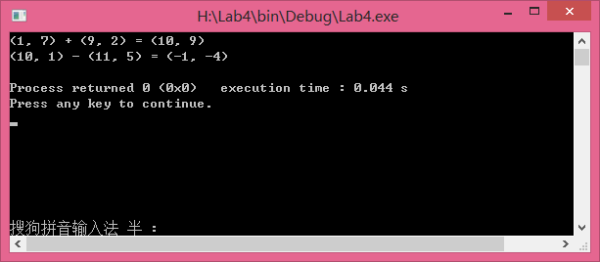

**V Follow-Up Questions and Activities**

1. Why do you think const was used in the parameter list of add and subtract?
2. Can add and subtract’s parameters be passed by value instead of by reference? How might this affect the design of class Complex? Write a new class definition that illustrates how the parameters would be passed by value.
3. Declare a Complex number, as follows, without passing any arguments to the constructor. What happens?Does the default constructor get called?

Complex a;

Answers：

1）因为加减运算中只需要求出结果，而不需要改变复数的值，

const使复数的值不能被修改。

2）

Complex Complex::add( const Complex right )

{

Complex c;

c.realPart=realPart+right.realPart;

c.imaginaryPart=imaginaryPart+right.imaginaryPart;

return c ;

} // end function add

Complex Complex::subtract( const Complex right )

{

Complex c;

c.realPart=realPart-right.realPart;

c.imaginaryPart=imaginaryPart-right.imaginaryPart;

return c;

} // end function subtract

3）对象被初始化为0，0。没有调用默认构造函数。 **Lab Exercise 5 — Dates**

**I Lab Objectives**

In this lab, you will practice:

1. Using access functions and utility functions so that it is not necessary for non-member functions to be able to access a class’ data members.

The follow-up questions and activities also will give you practice:

1. Overloading constructors and using default arguments with constructors.
2. Defining a destructor.

**II Description of the Problem**

Modify the Date class to provide a member function nextDay to increment the day by one. The Date object should always remain in a consistent state. Write a program that tests function nextDay in a loop that prints the date during each iteration to illustrate that the nextDay function works correctly. Be sure to test the following cases:

1. Incrementing into the next month.
2. Incrementing into the next year.

**III Sample Output**

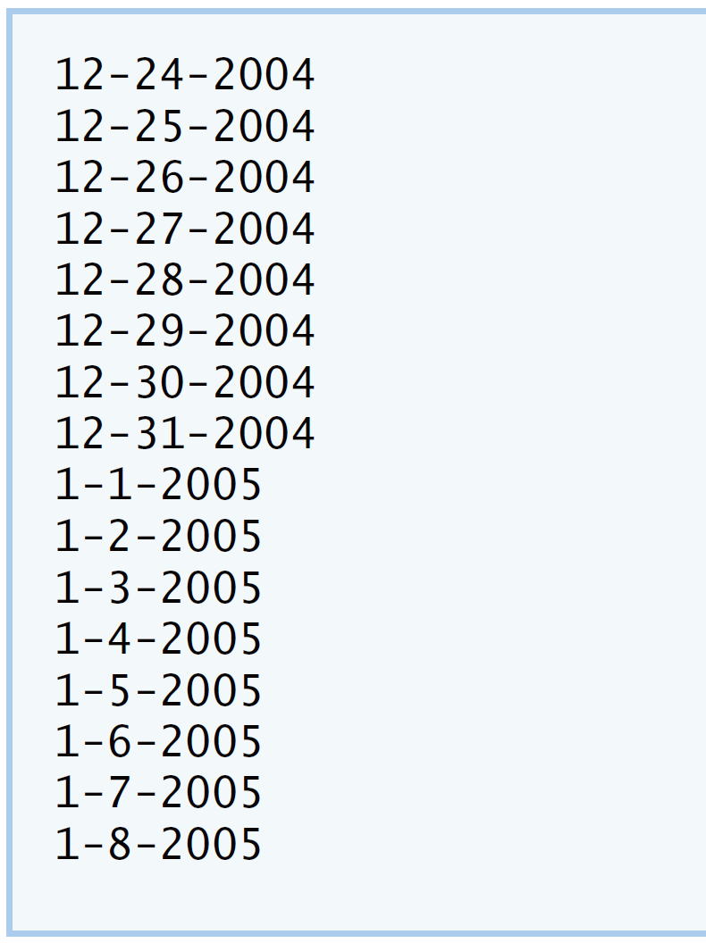

**IV Your Solution**

// Lab 5: Date.h

#ifndef DATE_H

#define DATE_H

class Date

{

public:

Date( int = 1, int = 1, int = 2000 ); // default constructor

~Date(); // default destructor

void print(); // print function

void setDate( int, int, int ); // set month, day, year

void setMonth( int ); // set month

void setDay( int ); // set day

void setYear( int ); // set year

int getMonth(); // get month

int getDay(); // get day

int getYear(); // get year

void nextday(); //date of next day

private:

int month; // 1-12

int day; // 1-31 (except February(leap year), April, June, Sept, Nov)

int year; // 1900+

bool leapYear(); // leap year

int monthDays(); // days in month

}; // end class Date

#endif

// Lab 5: Date.cpp

// Member-function definitions for class Date.

#include <iostream>

#include "Date.h" // include definition of class Date

using namespace std;

Date::Date( int m, int d, int y )

{

setDate( m, d, y ); // sets date

} // end Date constructor

Date::~Date()

{

cout<<"Destructor for the Date class was called successfully.\n";

} // end Date destructor

void Date::setDate( int mo, int dy, int yr )

{

setMonth( mo ); // invokes function setMonth

setDay( dy ); // invokes function setDay

setYear( yr ); // invokes function setYear

} // end function setDate

void Date::setDay( int d )

{

if ( month == 2 && leapYear() )

day = ( d <= 29 && d >= 1 ) ? d : 1;

else

day = ( d <= monthDays() && d >= 1 ) ? d : 1;

} // end function setDay

void Date::setMonth( int m )

{

month = m <= 12 && m >= 1 ? m : 1; // sets month

} // end function setMonth

void Date::setYear( int y )

{

year = y >= 1900 ? y : 1900; // sets year

} // end function setYear

int Date::getDay()

{

return day;

} // end function getDay

int Date::getMonth()

{

return month;

} // end function getMonth

int Date::getYear()

{

return year;

} // end function getYear

void Date::print()

{

cout << month << '-' << day << '-' << year << '\n'; // outputs date

} // end function print

void Date::nextday()

{

day++; //days plus one

if(day>monthDays()) //If the day bigger than monthDays,day reset to one,month plus one

{

day=1;

month+=1;

}

if(month>12) //If the month is bigger than 12,month reset to one,year plus one

{

month=1;

year+=1;

}

} // end function nextday

bool Date::leapYear()

{

if ( getYear() % 400 == 0 || ( getYear() % 4 == 0 && getYear() % 100 != 0 ) )

return true; // is a leap year

else

return false; // is not a leap year

} // end function leapYear

int Date::monthDays()

{

const int days[ 12 ] =

{ 31, 28, 31, 30, 31, 30, 31, 31, 30, 31, 30, 31 };

return getMonth() == 2 && leapYear() ? 29 : days[ getMonth() - 1 ];

} // end function monthDays

// Lab 5: DateTest.cpp

#include <iostream>

#include "Date.h" // include definitions of class Date

using namespace std;

int main()

{

const int MAXDAYS = 16;

Date d( 12, 24, 2004 ); // instantiate object d of class Date

// output Date object d's value

for ( int loop = 1; loop <= MAXDAYS; ++loop )

{

d.print(); // invokes function print

d.nextday(); // date of next day

} // end for

cout << endl;

} // end main

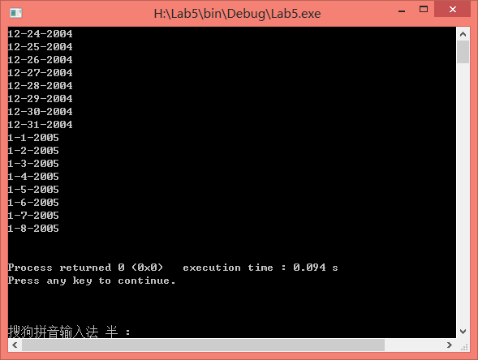

**V Follow-Up Questions and Activities**

1. The Date class has only one constructor. Is it possible to have more than one constructor?
2. What happens when a member function that takes no arguments is called without the parentheses (i.e.,dateObject.nextDay)?
3. Write a destructor for the Date class. The destructor should print text indicating that the destructor for the Date class was called successfully.
4. In main, try to change d’s year to 2003 using an assignment statement. Do not call function setYear. What happens? Are you able to change the value?

Answers：

1. 可以，一个类中可以有多个构造函数。
2. 编译器报错：error: statement cannot resolve address of overloaded function

Date::~Date()

{

cout<<"Destructor for the Date class was called successfully.\n";

} // end Date destructor

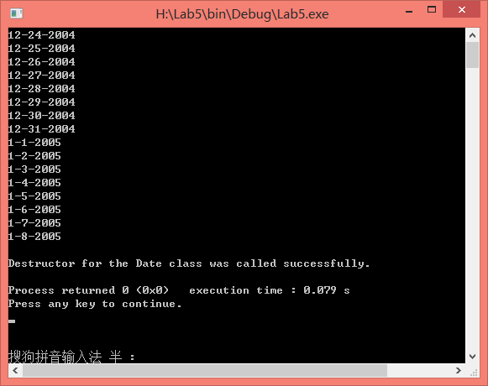

1. 编译器报错 ：
   * 1. 在数据成员year处报错：error:‘int Date::year' is private
     2. 在赋值语句处报错：error: within this context

不能改变year的值，因为year是私有的数据成员，只能通过调用set函数修改。

**Lab Exercise 6 — Simple Calculator**

**I Lab Objectives**

In this lab, you will practice:

1. Using classes to create a data type Simple Calculator capable of performing arithmetic operations.
2. Creating const member functions to enforce the principle of least privilege.

The follow-up questions and activities also will give you practice:

1. Using constructors to specify initial values for data members of a programmer-defined class.

**II Description of the Problem**

Write a SimpleCalculator class that has public methods for adding, subtracting, multiplying and dividing two doubles. A sample call is as follows:

double answer = sc.add( a, b );

Object sc is of type SimpleCalculator. Member function add returns the result of adding its two arguments.

**III Sample Output**

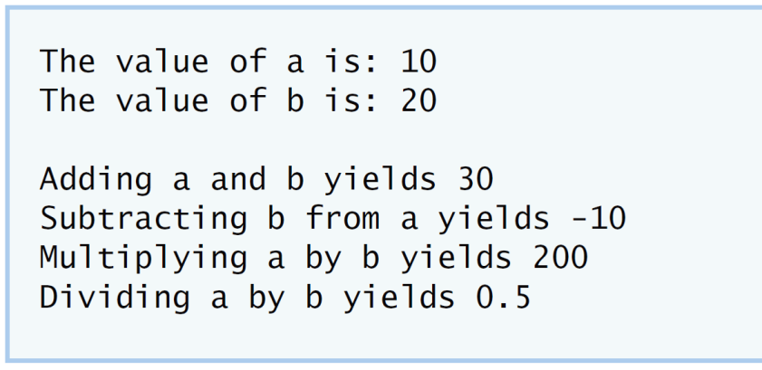

**IV Your Solution**

// Lab Exercise 6: SimpleCalculator.h

// class SimpleCalculator definition

class SimpleCalculator

{

public:

double add( double , double ) const; //add two numbers

double subtract( double, double ) const; //subtract two numbers

double multiply( double, double ) const; //multiply two numbers

double divide( double , double ) const; //divide two numbers

}; // end class SimpleCalculator

// Lab Exercise 6: SimpleCalculator.cpp

#include "SimpleCalculator.h"

// function add definition

double SimpleCalculator::add( double a, double b ) const

{

return a + b;

} // end function add

// function subtract definition

double SimpleCalculator::subtract( double a, double b ) const

{

return a - b;

} // end function subtract

// function multiply definition

double SimpleCalculator::multiply( double a, double b ) const

{

return a * b;

} // end function multiply

// function divide definition

double SimpleCalculator::divide( double a, double b ) const

{

return a / b;

} // end function divide

// Lab Exercise 6: CalcTest.cpp

#include <iostream>

#include "SimpleCalculator.h"

using namespace std;

int main()

{

double a = 10.0;

double b = 20.0;

SimpleCalculator sc;

cout << "The value of a is: " << a << "\n";

cout << "The value of b is: " << b << "\n\n";

double addition = sc.add( a, b );

cout << "Adding a and b yields " << addition << "\n";

double subtraction = sc.subtract( a, b );

cout << "Subtracting b from a yields " << subtraction << "\n";

double multiplication = sc.multiply( a, b );

cout << "Multiplying a by b yields " << multiplication << "\n";

double division = sc.divide( a, b );

cout << "Dividing a by b yields " << division << endl;

}

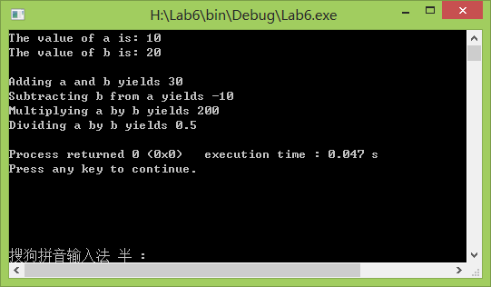

**V Follow-Up Questions and Activities**

1. Why doesn’t the SimpleCalculator class have a constructor?
2. Why are no private data members needed for class SimpleCalculator?
3. Modify your class so that SimpleCalculator has a private data member called answer. After performing an operation, assign the result to answer. Add a member function named getAnswer to retrieve the result of the last arithmetic operation performed by the object. Also, add a constructor for class SimpleCalculator that initializes the value of answer to 0.
4. Modify the program so that the SimpleCalculator class has an input member function that allows the user to input two doubles. The function should then store the values that were input in private data members. Use these two values for each of the arithmetic calculations. Create two constructors for this class, one that takes no arguments and initializes a and b to 0 and another that takes two doubles and initializes a and b to those values. Finally, create a member function printValues that displays the values of a and b. A segment of the driver program might now look like this:

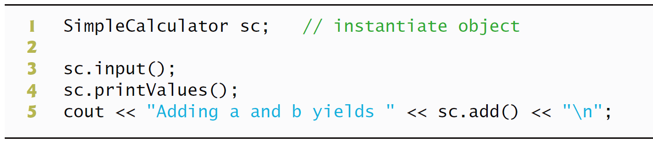

Answers：

1）构造函数用来初始化对象，而SimpleCalculator中没用数据成员，不需要初始化。

2）因为成员函数的所需的参数可以直接从main函数中读入，并得出计算结果，比有数据成员时的操作简单。

3）

class SimpleCalculator

{

public:

SimpleCalculator( double = 0 );

void add( double , double ); //add two numbers

void subtract( double, double ); //subtract two numbers

void multiply( double, double ); //multiply two numbers

void divide( double , double ); //divide two numbers

double getAnswer();

private:

double answer;

};

double SimpleCalculator::getAnswer()

{

return answer;

}

SimpleCalculator::SimpleCalculator(double dou)

:answer(0) {}

4）

class SimpleCalculator

{

public:

SimpleCalculator( );

SimpleCalculator( double, double );

double add( ); //add two numbers

double subtract( ); //subtract two numbers

double multiply( ); //multiply two numbers

double divide( ); //divide two numbers

void printValues();

void input();

private:

double answer;

double a;

double b;

};

void SimpleCalculator::input()

{

cout<<"请输入a和b的之值："<<endl;

double m, n;

cin>>m>>n;

a = m;

b = n;

}

void SimpleCalculator::printValues()

{

cout << "The value of a is: " << a << "\n";

cout << "The value of b is: " << b << "\n\n";

}

int main()

{

SimpleCalculator sc;

sc.input();

sc.printValues();

cout << "Adding a and b yields " << sc.add()<< "\n";

cout << "Subtracting b from a yields " << sc.subtract() << "\n";

cout << "Multiplying a by b yields " << sc.multiply() << "\n";

cout << "Dividing a by b yields " << sc.divide() << endl;

}

**\*Lab Exercise 7 — Integer Set**

**I Lab Objectives**

In this lab, you will practice:

1. Using classes to create a data type, IntegerSet, capable of storing a set of integers
2. Using dynamic memory allocation with the new and delete operators

The follow-up questions and activities also will give you practice:

1. Using destructors to deallocate memory that was dynamically allocated.

**II Description of the Problem**

Create class IntegerSet for which each object can hold integers in the range 0 through 100. A set is represented internally as an array of ones and zeros. Array element a[ i ] is 1 if integer *i* is in the set. Array element a[ j ] is 0 if integer *j* is not in the set. The default constructor initializes a set to the so-called “empty-set,” i.e., a set whose array representation contains all zeros.

Provide member functions for the common set operations. For example, aunionOfSets member function (already provided) creates a third set that is the set-theoretic union of two existing sets (i.e., an element of the third array’s is set to 1 if that element is 1 in either or both of the existing sets, and an element of the third set’s array is set to 0 if that element is 0 in each of the existing sets).

Provide an intersectionOfSetsmember function which creates a third set which is the set-theoretic intersection of two existing sets (i.e., an element of the third set’s array is set to 0 if that element is 0 in either or both of the existing sets, and an element of the third set’s array is set to 1 if that element is 1 in each of the existing sets).

An insertElement member function (already provided) inserts a new integer k into a set (by setting a[ k ] to 1 ). Provide a deleteElement member function that deletes integer m (by setting a[ m ] to 0 ).

A printSet member function (already provided) prints a set as a list of numbers separated by spaces. Print only those elements which are present in the set (i.e., their position in the array has a value of 1 ). Print --- for an empty set.

Provide anisEqualTo member function that determines whether two sets are equal.

Provide an additional constructor that receives an array of integers and the size of that array and uses the array to initialize a set object.

Now write a driver program to test your IntegerSet class. Instantiate several IntegerSet objects. Test that all your member functions work properly.

**III Sample Output**

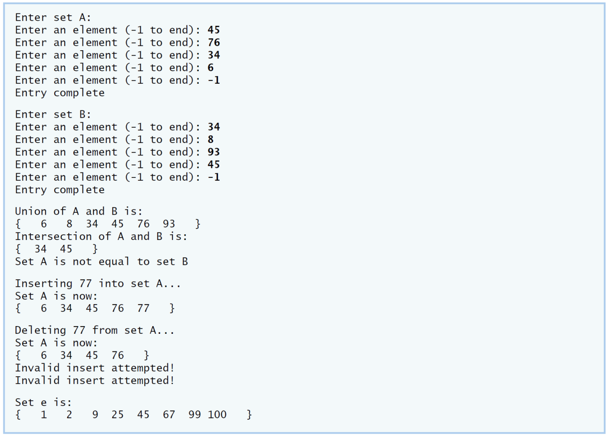

**IV Your Solution**

// Lab 7: IntegerSet.h

// Header file for class IntegerSet

#ifndef INTEGER_SET_H

#define INTEGER_SET_H

class IntegerSet

{

public:

// default constructor

IntegerSet()

{

emptySet();

} // end IntegerSet constructor

IntegerSet( int [], int ); // constructor that takes an initial set

IntegerSet unionOfSets( const IntegerSet& ); //union of two sets

IntegerSet intersectionOfSets( const IntegerSet& ); //intersection of two sets

void emptySet(); // set all elements of set to 0

void inputSet(); // read values from user

void insertElement( int ); //insert an element

void deleteElement( int ); //delete an element

void printSet() const; //print the set

bool isEqualTo( const IntegerSet& ) const; // determines if two sets are equal

private:

int set[ 101 ]; // range of 0 - 100

// determines a valid entry to the set

int validEntry( int x ) const

{

return ( x >= 0 && x <= 100 );

} // end function validEntry

}; // end class IntegerSet

#endif

// Lab 7: IntegerSet.cpp

// Member-function definitions for class IntegerSet.

#include <iostream>

#include <iomanip>

#include"IntegerSet.h"

using namespace std;

// constructor creates a set from array of integers

IntegerSet::IntegerSet( int array[], int size)

{

emptySet();

for ( int i = 0; i < size; i++ )

insertElement( array[ i ] );

} // end IntegerSet constructor

void IntegerSet::emptySet( )

{

for( int j = 0; j<101; j++)

set[j] = 0;

} // end function emptySet

// input a set from the user

void IntegerSet::inputSet()

{

int number;

do

{

cout << "Enter an element (-1 to end): ";

cin >> number;

if ( validEntry( number ) )

set[ number ] = 1;

else if ( number != -1 )

cerr << "Invalid Element\n";

} while ( number != -1 ); // end do...while

cout << "Entry complete\n";

} // end function inputSet

// prints the set to the output stream

void IntegerSet::printSet() const

{

int x = 1;

bool empty = true; // assume set is empty

cout << '{';

for (int u = 0; u < 101; u++ )

{

if ( set[ u ] )

{

cout << setw( 4 ) << u << ( x % 10 == 0 ? "\n" : "" );

empty = false; // set is not empty

x++;

} // end if

} // end for

if ( empty )

cout << setw( 4 ) << "---"; // display an empty set

cout << setw( 4 ) << "}" << '\n';

} // end function printSet

// returns the union of two sets

IntegerSet IntegerSet::unionOfSets( const IntegerSet &r )

{

IntegerSet temp;

// if element is in either set, add to temporary set

for ( int n = 0; n < 101; n++ )

if ( set[ n ] == 1 || r.set[ n ] == 1 )

temp.set[ n ] = 1;

return temp;

} // end function unionOfSets

// returns the intersection of two sets

IntegerSet IntegerSet::intersectionOfSets( const IntegerSet &r )

{

IntegerSet temp;

// if element is in either set, add to temporary set

for ( int n = 0; n < 101; n++ )

if ( set[ n ] == 1 && r.set[ n ] == 1 )

temp.set[ n ] = 1;

return temp;

} // end function intersectionOfSets

// insert a new integer into this set

void IntegerSet::insertElement( int k )

{

if ( validEntry( k ) )

set[ k ] = 1;

else

cerr << "Invalid insert attempted!\n";

} // end function insertElement

// delete a integer into this set

void IntegerSet::deleteElement( int m )

{

if ( validEntry( m ) )

set[ m ] = 0;

else

cerr << "Invalid delete attempted!\n";

} // end function deleteElement

// determines if two sets are equal

bool IntegerSet::isEqualTo( const IntegerSet &r ) const

{

for ( int v = 0; v < 101; v++ )

if ( set[ v ] != r.set[ v ] )

return false; // sets are not-equal

return true; // sets are equal

} // end function isEqualTo

// Lab 7: SetTest.cpp

// Driver program for class IntegerSet.

#include <iostream>

#include "IntegerSet.h" // IntegerSet class definition

using namespace std;

int main()

{

IntegerSet a;

IntegerSet b;

IntegerSet c;

IntegerSet d;

cout << "Enter set A:\n";

a.inputSet();

cout << "\nEnter set B:\n";

b.inputSet();

c=a.unionOfSets(b); //union of two sets

d=a.intersectionOfSets(b); //intersection of two sets

cout << "\nUnion of A and B is:\n";

c.printSet();

cout << "Intersection of A and B is:\n";

d.printSet();

if ( a.isEqualTo( b ) )

cout << "Set A is equal to set B\n";

else

cout << "Set A is not equal to set B\n";

cout << "\nInserting 77 into set A...\n";

a.insertElement( 77 );

cout << "Set A is now:\n";

a.printSet();

cout << "\nDeleting 77 from set A...\n";

a.deleteElement( 77 );

cout << "Set A is now:\n";

a.printSet();

const int arraySize = 10;

int intArray[ arraySize ] = { 25, 67, 2, 9, 99, 105, 45, -5, 100, 1 };

IntegerSet e( intArray, arraySize );

cout << "\nSet e is:\n";

e.printSet();

cout << endl;

} // end main

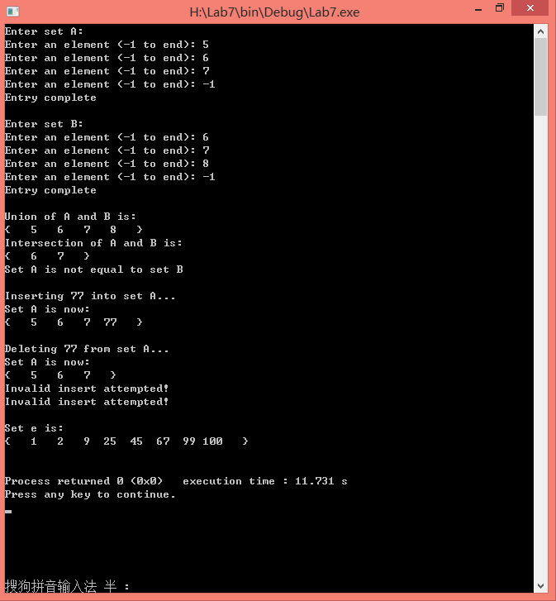

**V Follow-Up Questions and Activities**

1. Why might it be advantageous for the set array to be allocated dynamically using new [], if the IntegerSet class were to be used for more general sets?

Answer：

1）new可以动态的为数组分配空间，更加节省空间。